
Kolbe Catholic College

YEAR 12 CHEMISTRY EXAMINATION

SEMESTER ONE 2001

STUDENT NAME: __________________________________________

TIME ALLOWED FOR THIS PAPER

Reading time before commencing work: Ten minutes
Working time for paper: Two hours and 30 minutes
The examiners recommend that candidates spend the reading time mainly reading the Instructions to Candidates and Parts 2, 3 and 4.
MATERIAL REQUIRED/RECOMMENDED FOR THIS PAPER
TO BE PROVIDED BY THE SUPERVISOR
This Question Answer Booklet comprising 37 pages
Separate Multiple Choice Answer Sheet
Separate Chemical Data Sheet (inside front cover of this Question/Answer Booklet)

TO BE PROVIDED BY THE CANDIDATE
Standard Items: Pens, pencils, eraser, ruler.
Special Items: A calculator satisfying the conditions set by the Curriculum Council and a '2B' pencil for the separate Multiple Choice Answer Sheet.

IMPORTANT NOTE TO CANDIDATES

No other items may be taken into the examination room.
It is your responsibility to ensure that you do not have any unauthorised notes or other items of a non-personal nature in the examination room. If you have any unauthorised material with you, hand it to the supervisor BEFORE reading any further.

PART | MARKS
1 | 60
2 | 70
3 | 50
4 | 20
TOTAL | 200

INSTRUCTIONS TO CANDIDATES

This paper consists of FOUR PARTS as follows:

PART 1 contains 30 questions and is a MULTIIPLE CHOICE test.

Answer ALL questions in Part 1 on the Separate Multiple Choice Answer Sheet. Use a '2B' PENCIL. DO NOT USE A BALL POINT OR INK PEN.

If you consider that two or more of the alternative answers are correct, choose the one you think is best. If you think you know an answer, mark it even if you are not certain you are correct. Marks will NOT be deducted for incorrect answers.

This part is worth 60 marks (30% of the total) and should take 55 minutes.

PART 2 contains 8 SHORT ANSWER questions. You should
answer ALL the questions. The answers are to be written in the spaces provided in this Question Answer Booklet.

This part is worth 70 marks (35% of the total) and should take about 60 minutes.

PART 3 contains 6 CALCULATIONS. You should answer ALL the
questions in detail in this Question/Answer Booklet.

This part is worth 50 marks (25% of the total) and should take about 45 minutes.

PART 4 contains a choice of EXTENDED ANSWER questions. You should answer ONE of these questions and write your answer on the lined spaces provided.

This part is worth 20 marks (10% of the total) and should take about 20 minutes.

Total for paper = 180 marks

At the end of the examination make sure that your name is on your question Answer/Booklet and your separate Multiple Choice Answer Sheet.

PART 1 – MULTIPLE CHOICE

Answer ALL questions in Part 1 by filling in the multiple choice answer sheet provided. This part consists of 60 marks.

- Consider the reaction at equilibrium at 1000ºC:

2CO(g) + O₂(g) 2CO₂(g) ΔH = -566 kJ mol⁻¹

Which change would result in a larger concentration of CO₂?

- Decreasing the volume
- Increasing the temperature
- Adding a catalyst
- Decreasing the partial pressure of CO(g)

- Which of the following solutions has the highest pH?

- 0.08 mol L⁻¹ sulfuric acid
- 0.08 mol L⁻¹ hydrochloric acid
- 0.08 mol L⁻¹ acetic acid
- 0.04 mol L⁻¹ nitric acid

- When chloride ions are added to a solution containing Co(H₂O)₆²⁺ the following equilibrium is established:

Co(H₂O)₆²⁺ (aq) + 4Cl⁻ (aq) CoCl₄²⁻ (aq) + 6 H₂O(l)

Pink Blue

Solutions containing Co(H₂O)₆²⁺ and Cl⁻ are frequently violet in colour owing to the presence of significant amounts of Co(H₂O)₆²⁺ and CoCl₄²⁻.

Which of the following statements concerning such solutions is true?

- Diluting the solution with water will make the colour turn blue.
- If the reaction is endothermic, cooling the solution will make the colour turn pink.
- If the reaction is exothermic, heating the solution will make the colour turn blue.
- Adding a large amount of solid NaCl to the solution will make the colour turn pink.

- 1 mol L⁻¹ of compound A decomposes according to the equation:

2A(g) B(g) + C(g)

The following diagram shows the progress of the reaction.

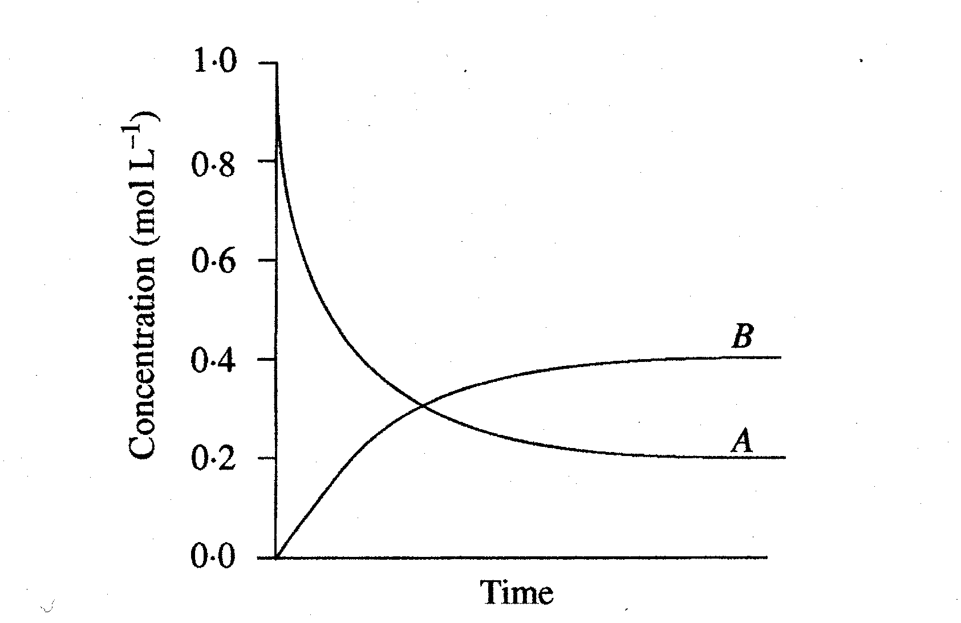

What is the equilibrium constant for the reaction?

- 0.8
- 2.0
- 4.0
- 10.0

- Which of the following describes an electrochemical cell?

 | Eº_{cell} | Type of Reaction
(A) | Positive | Spontaneous
(B) | Positive | Non-Spontaneous
(C) | Negative | Spontaneous
(D) | Negative | Non-Spontaneous

Natural gas burns to give much energy, and yet a spark or flame must be used to start combustion. Why?

(A) the gas combustion is an endothermic process
(B) an energy barrier must be overcome to begin the reaction
(C) both (A) and (B) are true
(D) ΔH for this reaction is very small

- Flour may be safely stored in the pantry, but flour “dust” is highly explosive. What is the main contributing factor to this?

(A) the coolness of the pantry
(B) the larger heat content of the dust
(C) the greater concentration of the dust
(D) the larger surface area of the dust

- Which of the following is FALSE regarding reaction rates?

- increasing the concentration of reacting particles increases the chance of collisions
- optimum collision geometry lowers the activation energy barrier
- a reaction occurs each time particles of the reactants collide
- the slowest reaction involved in a reaction mechanism determines the rate of the overall reaction

- Which of the following is a list of metals in order from strongest to weakest reducing agents?

- K > Ni > Sn
- Ni > K > Sn
- Ni > Sn > K
- Sn > Ni > K

- The conjugate base of H₂PO₄⁻ is

- PO₄³⁻
- HPO₄⁻
- HPO₄²⁻
- H₃PO₄

- When 10.0 mL of 0.10 M HCl is added to 10.0 mL of water, the concentration of H₃O⁺ in the final solution is

- 0.010 M
- 0.050 M
- 0.10 M
- 0.20 M

- Iodine is a solid that forms a brown solution in water

I₂(s) I₂(aq)

The system is at equilibrium.

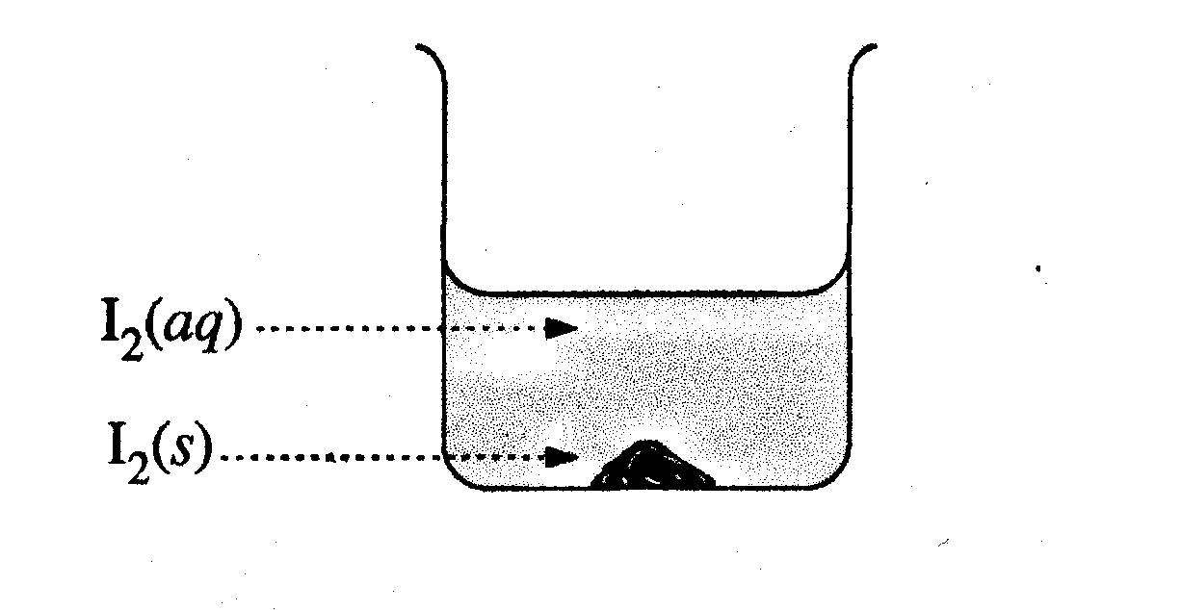
Adding more solid iodine will

- make the solution darker brown
- make the solution lighter brown
- have no effect on the equilibrium
- result in an increase in the concentration of I₂(aq)

- In an equilibrium system, continuing microscopic changes indicate that the equilibrium is

- dynamic
- complete
- exothermic
- spontaneous

- Consider the following Potential Energy (PE) diagram:

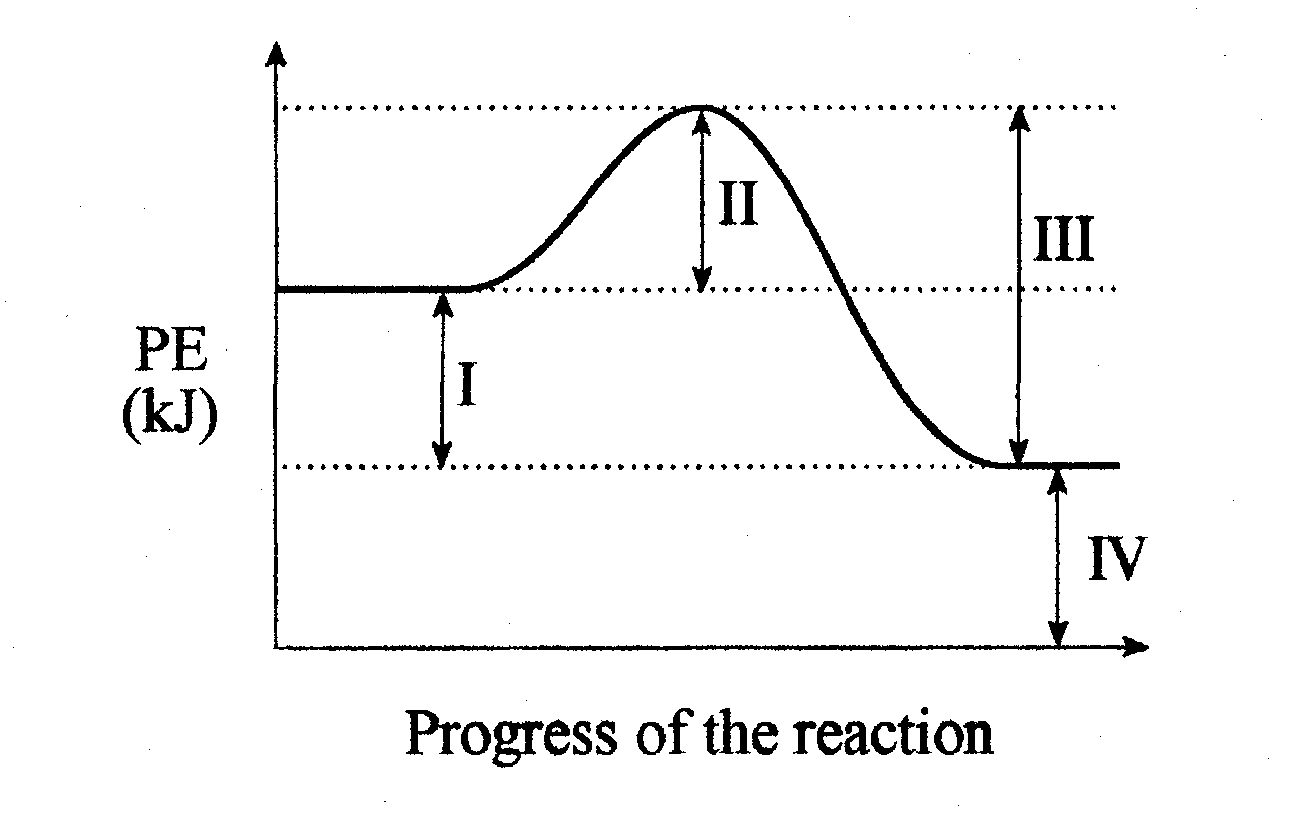

The activation energy for the forward reaction is represented by

- I
- II
- III
- IV

- What is the concentration of barium ions in 1.00 L solution containing 2.08 g of BaCl₂?

- 1.00 x 10⁻² M
- 1.21 x 10⁻² M
- 2.00 x 10⁻² M
- 2.08 M

- A precipitate forms when a 0.20 M solution containing an unknown cation is added to SO₄²⁻, but not when an equal volume is added to OH⁻.
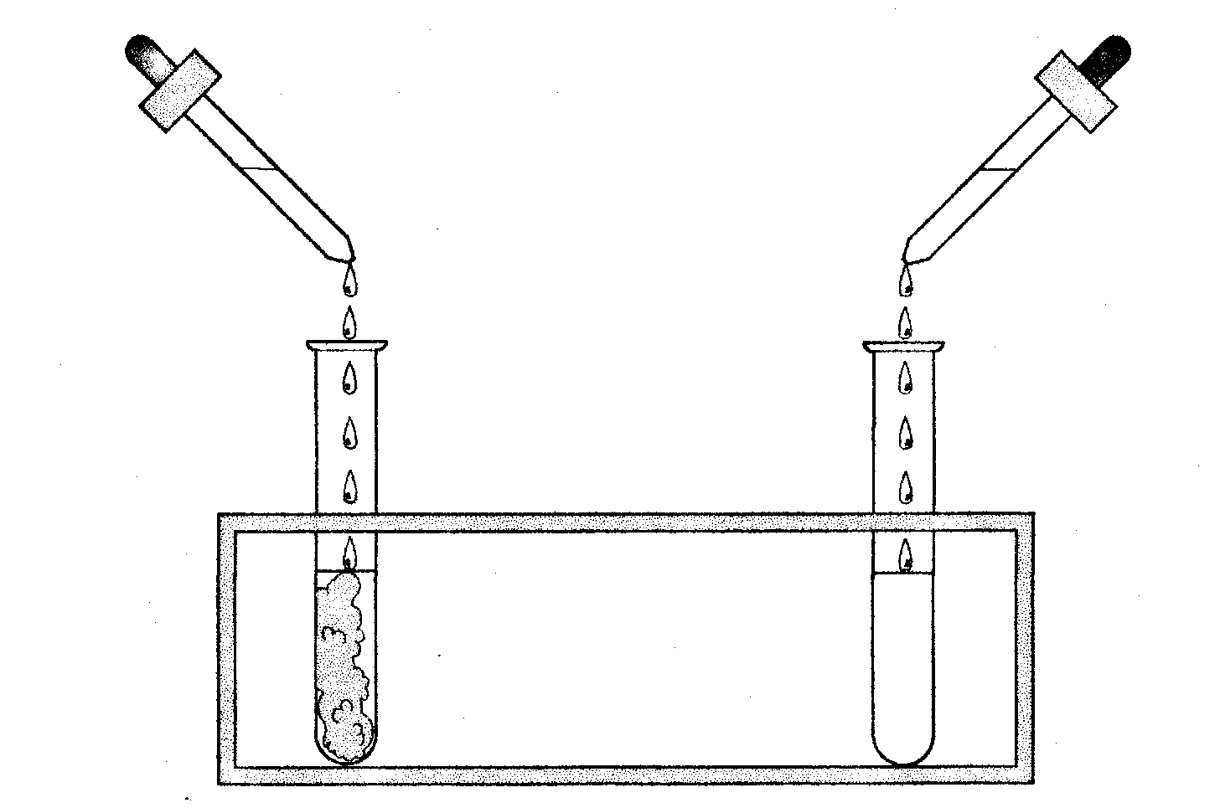
0.20 M unknown cation
0.20 M unknown cation
0.20 M SO₄²⁻
0.20 M OH⁻

The unknown cation is

- Na⁺
- Hg²⁺
- Pb²⁺
- Ba²⁺

- Equal volumes of 1.0 M solutions of AuCl₃ and FeCl₂ are mixed. the reaction products are
(A) Fe and Au
(B) Fe and Au³⁺
(C) Fe²⁺ and Au
(D) Fe³⁺ and Au

- A galvanic cell is constructed by placing a platinum wire in a solution that is 1 M in Sn²⁺ ion and 1 M in Sn⁴⁺ ion. This solution is connected by means of a salt bridge to a solution that is 1 M in Cu²⁺. A copper wire in this second solution completes the circuit. The oxidizing agent in this cell is

(A) Pt
(B) Cu²⁺
(C) Sn⁴⁺
(D) Sn²⁺

- Sodium chloride acts as an electrolyte because sodium chloride

(A) is soluble in water
(B) is held together by covalent bonds
(C) produces ions when it dissolves in water
(D) is a crystalline solid

- Consider the following cells:

(i) the zinc-carbon "dry cell"
(ii) the lead storage battery
(iii) the nickel-cadmium cell
(iv) the hydrogen-oxygen fuel cell
The cells that can be recharged are

(A) Only (i) and (ii)
(B) Only (ii) and (iii)
(C) Only (iii) and (iv)
(D) Only (ii), (iii), and (iv)

- One difference between a battery and a fuel cell is

(A) the sign of the electrodes.
(B) that batteries involve oxidation - reduction and fuel cells do not
(C) that fuel cells have not been used to power automobiles
(D) fuel cells have a constantly replenished source or supply of reactants

- The reaction that occurs at the anode of the lead-acid (automobile) battery is

(A) Pb (s) + SO₄²⁻ (aq) -> PbSO₄ (s) + 2 e⁻
(B) PbO₂ (s) + 4 H⁺ + SO₄²⁻ (aq) + 2 e⁻ -> PbSO₄ (s) + 2 H₂O (l)
(C) Zn (s) -> Zn²⁺ (aq) + 2 e⁻
(D) 2 H⁺ (aq) + 2 e⁻ -> H₂ (g)

- Consider the following equations:

(i) Zn (s) + I₂ (s) ---> ZnI₂ (s)
- H₂CO₃ (aq) ---> H₂O (l) + CO₂ (g)
- SO₃ (g) + K₂O (s) ---> K₂SO₄ (s)

Which equation(s) represent redox reactions?

- (i)
- (iii)
- (i) and (ii)
- (i) and (iii)

- The spectator ions in the precipitation reaction of lead(II) nitrate with sodium sulfide are

- Pb²⁺ and S²⁻
- Na⁺ and NO₃⁻
- Na⁺ and SO₄²⁻
(D) Pb²⁺ and NO₃⁻

- Consider the following half equations:

Ag⁺ (aq) + e⁻ -----> Ag (s) Eº = +0.80 V
Ni²⁺ (aq) + 2e⁻ -----> Ni (s) Eº = -0.26

Which of the following statements is true:

(A) electrons flow in the external circuit from silver to nickel
(B) the Ag electrode is the anode
(C) Ni²⁺ is reduced to Ni
- Ag⁺ is reduced to Ag

- The standard EMF for the cell described above is

(A) 0.54 V
- (B) 1.06 V
(C) - 0.54
(D) – 1.06

- Consider the following reaction:

14H⁺ (aq) + Cr₂O₇²⁻ (aq) + 3Ni (s) -----> 3Ni²⁺ (aq) + 2Cr³⁺ (aq) + 7H₂O (l)

The oxidising agent in this reaction is

(A) H⁺
(B) Cr₂O₇²⁻
(C) Ni
(D) Cr³⁺

- The oxidation number of manganese in KMnO₄ is

(A) +3
(B) +5
(C) +7
(D) +9

- The oxidation number of gold in K₃[Au(CN)₄]

(A) +1
(B) +2
(C) +3
(D) +4

- What is the stoichiometric coefficient for ZnS (s) in the following equation when it is correctly balanced? Assume acidic conditions.

(A) 1
(B) 2
(C) 3
(D) 4

END OF PART 1

Student Name ______________________________

PART 2 – SHORT ANSWERS

Answer ALL questions in Part 2 in the spaces provided. This part consists of 8 questions worth 70 marks.

- A sodium acetate (NaCH₃COO) solution has a pH of 8, while an ammonium chloride (NH₄Cl) solution has a pH of 5.

Write ionic equations to show why:

- a solution of NaCH₃COO has a pH higher than 7;
[2 marks]

________________________________________________________________________

- a solution of NH₄Cl has a pH lower than 7.
[2 marks]

________________________________________________________________________

________________________________________________________________________

________________________________________________________________________

________________________________________________________________________

- A student constructed two electrochemical cells as shown. The aqueous cell solutions had a concentration of 1 mol L⁻¹ with respect to the metal ions present.
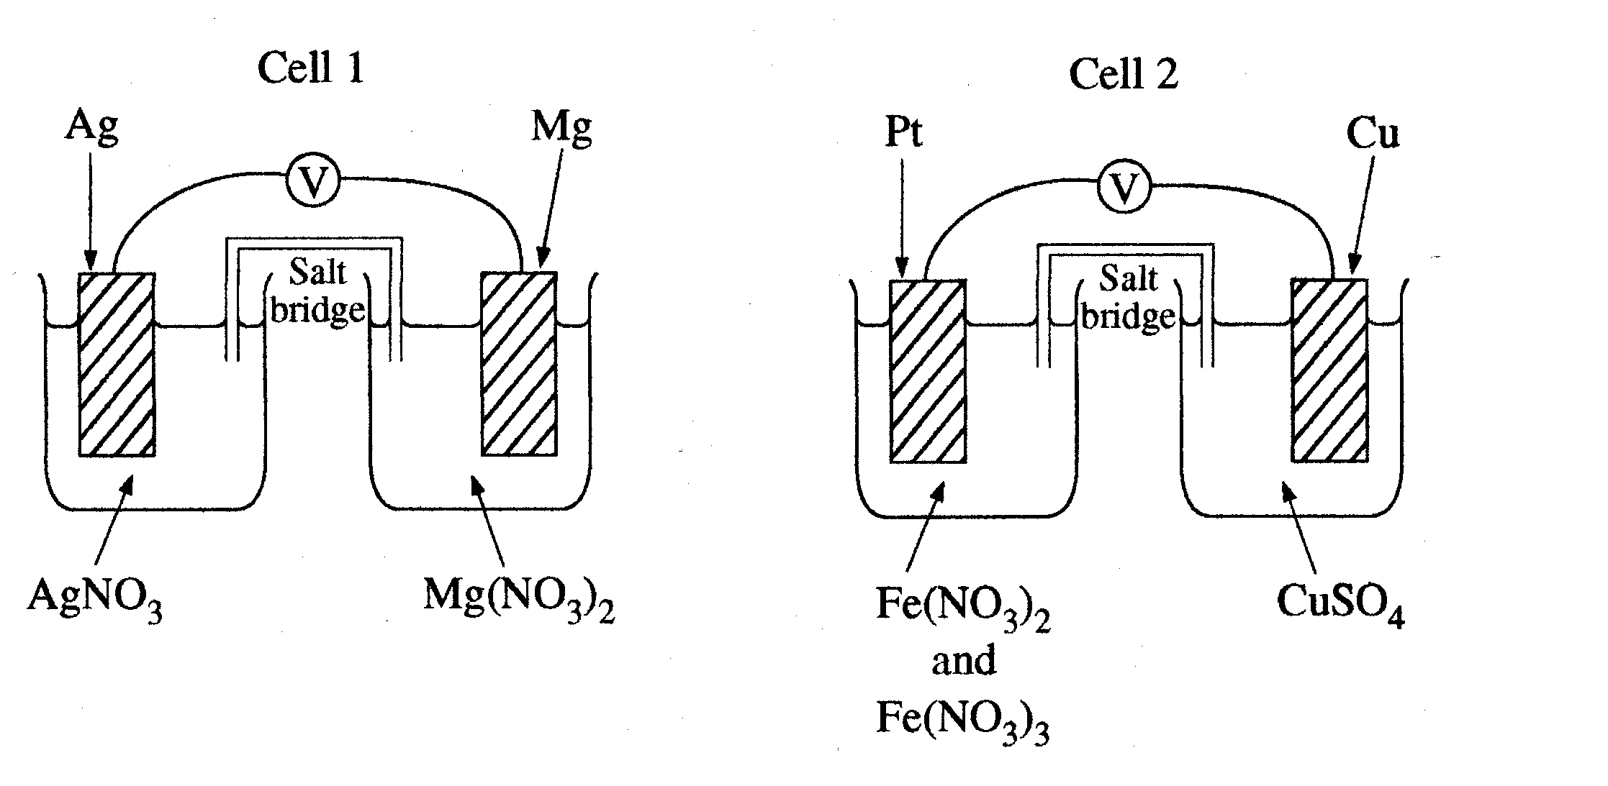

- Use equations to describe the chemical changes that occur in Cell 1 as the cell operates.
[2 marks]

________________________________________________________________________

________________________________________________________________________

________________________________________________________________________

________________________________________________________________________

________________________________________________________________________

________________________________________________________________________

________________________________________________________________________

________________________________________________________________________

________________________________________________________________________

________________________________________________________________________

________________________________________________________________________

________________________________________________________________________

- In Cell 2, the solution in one half-cell is initially an orange colour due to the mixture of the pale green Fe²⁺ ions and the orange Fe³⁺ ions. The other half is coloured blue due to the Cu²⁺ ions. Describe the colour changes the student would see in each half of Cell 2 if the reaction proceeded until no further change took place.
[5 marks]

________________________________________________________________________

________________________________________________________________________

________________________________________________________________________

________________________________________________________________________

________________________________________________________________________

________________________________________________________________________

________________________________________________________________________

________________________________________________________________________

________________________________________________________________________

________________________________________________________________________

- Calculate the initial potential difference across Cell 1.
[1 mark]

________________________________________________________________________

________________________________________________________________________

________________________________________________________________________

________________________________________________________________________

________________________________________________________________________

________________________________________________________________________

________________________________________________________________________

- As the reaction proceeds, the voltage in the cell drops. Explain.
[2 marks]

________________________________________________________________________

________________________________________________________________________

________________________________________________________________________

________________________________________________________________________

________________________________________________________________________

________________________________________________________________________

- What is the purpose of the salt bridge joining each half-cell?
[1 mark]

________________________________________________________________________

________________________________________________________________________

________________________________________________________________________

________________________________________________________________________

________________________________________________________________________

________________________________________________________________________

- In Cell 2, what is the oxidising agent, and at which electrode does oxidation occur?
[2 marks]

________________________________________________________________________

________________________________________________________________________

________________________________________________________________________

________________________________________________________________________

The following unbalanced equation partially describes the process that occurs when potassium bromate solution, KbrO₃, is mixed with oxalic acid, (COOH)₂.

BrO₃⁻ (aq) + (COOH)₂ (aq) -----> Br⁻ (aq) + CO₂(g)

- What is the oxidation number of bromine in the bromate ion?
[1 mark]

________________________________________________________________________

- Which species is being oxidised?
[1 mark]

________________________________________________________________________

- Write the balanced oxidation half-equation.
[1 mark]

________________________________________________________________________

________________________________________________________________________

- Write the balanced reduction half-equation.
[1 mark]
________________________________________________________________________

________________________________________________________________________

- Write the balanced overall equation for the reaction.
[1 mark]

________________________________________________________________________

________________________________________________________________________

- Write equations for any reactions that occur in the following procedures. If no reaction occurs write ‘no reaction’.

In each case describe in full what you would observe, including any
(i) colours
(ii) odours
(iii) precipitates (give the colour)
(iv) gases evolved (give the colour or describe as colourless)

If no change is observed, you should state this.

- A piece of magnesium is immersed in copper(II) sulfate solution
[3 marks]

Equation ____________________________________________________________

Observation _________________________________________________________

____________________________________________________________________

- A syringe full of nitrogen dioxide is compressed by a student to the point where no more compression is physically possible
[3 marks]

Equation ____________________________________________________________

Observation _________________________________________________________

____________________________________________________________________

- Twenty drops of 0.2 mol L⁻¹ hydrochloric acid is added to 1 mL of potassium chromate
[3 marks]

Equation ____________________________________________________________

Observation _________________________________________________________

- 3 mL of 2 mol L⁻¹ of hydrochloric acid is added to a small quantity of sodium sulfide.
[3 marks]

Equation ____________________________________________________________

Observation _________________________________________________________

____________________________________________________________________

- 3 mL of 2 mol L⁻¹ of hydrochloric acid is added to a small quantity of sodium sulfite and the system heated gently.
[3 marks]

Equation ____________________________________________________________

Observation _________________________________________________________

____________________________________________________________________

- Consider these ten compounds:
[15 marks]

(a) Na₂SO₄ (b) HNO₃ (c) MgO (d) NH₃ (e) CaCO₃

(f) Fe(NO₃)₃ g) CH₃COOH (h) AgCl (i) SO₃

(j) KOH

Answer the following questions by writing the formulas of the compounds in the space provided below. Write NONE if no compound in the list is an answer to the question.

Note: Some of the compounds may be used more than once, others may not be used at all.

(i) Which compound is a strong acid? ________________________________

(ii) Which compound is a weak acid? ________________________________

(iii) Which two compounds are soluble salts? __________________________

(iv) Which two compounds are insoluble salts? ________________________

(v) Which compound is a strong base? _______________________________

(vi) Which compound is a weak base? _______________________________

(vii) Which compound is an acidic oxide? ____________________________

(viii) Which compound is a basic oxide? _____________________________

(ix) Which two compounds dissolve in water to give weakly conducting solutions?
________________________________________________

(x) Which compound produces no ions when it dissolves in water? _________

(xi) Which two compounds react with each other to produce iron(III) hydroxide?
________________________________________________

- Write the equilibrium constant expression for the following reactions:
[6 marks]

(i) C₃H₇OH (l) + CH₃COOH (l) CH₃COOC₃H₇ (l) + H₂O (l)

K_{eq} = __________________________

(ii) 2H₂ (g) + O₂ (g) 2H₂O (g)

K_{eq} = __________________________

(iii) NH₄Cl (s) NH₃ (g) + HCl (g)

K_{eq} = __________________________

(iv) H₂O (l) H⁺ (aq) + OH⁻ (aq)

K_{eq} = __________________________

(v) C₁₂H₂₂O₁₁ (s) C₁₂H₂₂O₁₁ (aq)

K_{eq} = __________________________

(vi) 4Al (s) + 3O₂ (g) + 6H₂O (l) 4Al(OH)₃ (s)

K_{eq} = __________________________

7. Consider the reaction: CO + 2H₂ CH₃OH. All substances are in the gaseous state and ΔH = -92 kJ. Predict whether the reactsnts or the products will be favoured by the following changes:

[4 marks]

(i) increased pressure ____________________________________

- increased temperature _________________________________

- addition of hydrogen __________________________________

- removal of the product CH₃OH __________________________

8. Balance each of the following equations, and then write the net ionic equation. Show states for all reactants and products (s, l, g, aq)
[8 marks]

(i) Ba(OH)₂ + HNO₃ ------> Ba(NO₃)₂ + H₂O
________________________________________________________________________

________________________________________________________________________

________________________________________________________________________

________________________________________________________________________

________________________________________________________________________

(ii) BaCl₂ + Na₂CO₃ -----> BaCO₃ + NaCl

________________________________________________________________________

________________________________________________________________________

________________________________________________________________________

________________________________________________________________________

________________________________________________________________________

(iii) Na₃PO₄ + Ni(NO₃)₂ -----> Ni₃(PO₄)₂ + NaNO₃

________________________________________________________________________

________________________________________________________________________

________________________________________________________________________

________________________________________________________________________

________________________________________________________________________

(iv) NaOH + FeCl₂ -----> Fe(OH)₂ + NaCl

________________________________________________________________________

________________________________________________________________________

________________________________________________________________________

________________________________________________________________________

________________________________________________________________________

END OF PART 2

Student Name ______________________________

PART 3 – CALCULATIONS

Answer ALL questions in Part 3 in detail in the spaces provided. This part consists of 6 questions worth 50 marks.

1. A chemist dissolved the calcium carbonate in a section of blocked pipe by soaking the section in an excess (100.0 mL) of 0.200 mol L⁻¹ hydrochloric acid. After the calcium carbonate had dissolved, the unused hydrochloric acid was titrated with 0.100 mol L⁻¹ sodium hydroxide. 33.3 mL of 0.100 mol L⁻¹ sodium hydroxide was required.

(i) Write the equation for the reaction of calcium carbonate with hydrochloric acid.

[1 mark]

________________________________________________________________________

(ii) Calculate the number of moles of sodium hydroxide that were required to neutralise the unreacted hydrochloric acid.
[1 mark]

________________________________________________________________________

________________________________________________________________________

________________________________________________________________________

________________________________________________________________________

________________________________________________________________________

________________________________________________________________________

________________________________________________________________________

________________________________________________________________________

________________________________________________________________________

- Calculate the number of moles of hydrochloric acid that reacted with the calcium carbonate.

[2 marks]
________________________________________________________________________

________________________________________________________________________

________________________________________________________________________

________________________________________________________________________

________________________________________________________________________

________________________________________________________________________

________________________________________________________________________

- Calculate the mass of calcium carbonate (in grams) that existed in the pipe.

[2 marks]

________________________________________________________________________

________________________________________________________________________

________________________________________________________________________

________________________________________________________________________

________________________________________________________________________

________________________________________________________________________

________________________________________________________________________

________________________________________________________________________

________________________________________________________________________

________________________________________________________________________

________________________________________________________________________

2. Sodium reacts violently with water to produce hydrogen gas in a strongly exothermic reaction.

0.23 g of sodium was placed carefully in 100 mL of water containing 3 drops of phenolphthalein indicator. The resulting solution was pink in colour.

- Write a balanced equation to show the reaction that occurred between the water and the sodium.

[1 mark]

________________________________________________________________________

- Calculate the pH of the solution that resulted from the addition of 0.23 g of sodium to 100 mL of water at 25ºC.

[4 marks]

________________________________________________________________________

________________________________________________________________________

________________________________________________________________________

________________________________________________________________________

________________________________________________________________________

________________________________________________________________________

________________________________________________________________________

________________________________________________________________________

________________________________________________________________________

________________________________________________________________________

________________________________________________________________________

________________________________________________________________________

3. The three-step Ostwald process for manufacturing Nitric Acid, HNO₃ is as follows:
4 NH₃(g) + 5 O₂(g) ------> 4 NO(g) + 6 H₂O(g)
2 NO(g) + O₂(g) ------> 2 NO₂(g)
3 NO₂(g) + H₂O(l) ---- -> 2 HNO₃(aq) + NO(g)
Calculate the mass of ammonia is required to produce 75.0 g HNO₃?
[5 marks]

________________________________________________________________________

________________________________________________________________________

________________________________________________________________________

________________________________________________________________________

________________________________________________________________________

________________________________________________________________________

________________________________________________________________________

________________________________________________________________________

________________________________________________________________________

________________________________________________________________________

________________________________________________________________________

________________________________________________________________________

________________________________________________________________________

________________________________________________________________________

________________________________________________________________________

________________________________________________________________________

________________________________________________________________________
4. A sample of iron was analysed by dissolving 1.374 g of it in excess sulfuric acid. The solution was then treated with zinc to reduce all the iron present in solution to Fe²⁺ (aq). The resulting solution was diluted to 100 mL in a volumetric flask and 25.00 mL samples of it are titrated with acidified 2.191 x 10⁻² mol L⁻¹ KMnO₄ solution. On average 35.15 mL of the KMnO₄ solution was needed for equivalence. What maximum mass of iron can be extracted from 1.5 tonne of this iron ore? (1 tonne = 1000 kg)
[9 marks]

________________________________________________________________________

________________________________________________________________________

________________________________________________________________________

________________________________________________________________________

________________________________________________________________________

________________________________________________________________________

________________________________________________________________________

________________________________________________________________________

________________________________________________________________________

________________________________________________________________________

________________________________________________________________________

________________________________________________________________________

________________________________________________________________________

________________________________________________________________________

________________________________________________________________________

________________________________________________________________________

________________________________________________________________________

________________________________________________________________________

________________________________________________________________________

________________________________________________________________________

________________________________________________________________________

________________________________________________________________________

________________________________________________________________________

________________________________________________________________________

________________________________________________________________________

________________________________________________________________________

________________________________________________________________________

________________________________________________________________________

________________________________________________________________________

________________________________________________________________________

________________________________________________________________________

________________________________________________________________________

________________________________________________________________________

________________________________________________________________________

________________________________________________________________________

________________________________________________________________________

________________________________________________________________________

________________________________________________________________________

________________________________________________________________________

________________________________________________________________________

________________________________________________________________________

________________________________________________________________________

5. Aspartame is a compound used as an artificial sweetener in foods and beverages. It contains the elements carbon, hydrogen, oxygen and nitrogen. To determine its empirical formula a 7.335 g sample was completely burnt in oxygen. The resulting carbon dioxide and water were collected and found to weigh 15.36 g and 4.041 g respectively. A second 4.719 g aspartame sample was treated to convert the nitrogen it contained into ammonia (NH₃). The resulting ammonia was absorbed into 100.0 mL of 0.3559 mol L⁻¹ HCl (aq). The excess HCl(aq) was then titrated to equivalence using 28.18 mL of 0.1249 mol L⁻¹ NaOH (aq). Determine the empirical formula for aspartime.
[15 marks]
________________________________________________________________________

________________________________________________________________________

________________________________________________________________________

________________________________________________________________________

________________________________________________________________________

________________________________________________________________________

________________________________________________________________________

________________________________________________________________________

________________________________________________________________________

________________________________________________________________________

________________________________________________________________________

________________________________________________________________________

________________________________________________________________________

________________________________________________________________________

________________________________________________________________________

________________________________________________________________________

________________________________________________________________________

________________________________________________________________________

________________________________________________________________________

________________________________________________________________________

________________________________________________________________________

________________________________________________________________________

________________________________________________________________________

________________________________________________________________________

________________________________________________________________________

________________________________________________________________________

________________________________________________________________________

________________________________________________________________________

________________________________________________________________________

________________________________________________________________________

________________________________________________________________________

________________________________________________________________________

________________________________________________________________________

________________________________________________________________________

________________________________________________________________________

________________________________________________________________________

________________________________________________________________________

________________________________________________________________________

________________________________________________________________________

________________________________________________________________________

________________________________________________________________________
6. Triple superphosphate is a fertiliser produced by mixing phosphoric acid with insoluble rock phosphate. It is important to add the reagents in the correct stoichiometric ratio so that there is no wastage of rock phosphate and no excess of phosphoric acid in the resulting fertiliser. A particular batch of triple superphosphate is prepared by combining 4.92 tonnes of rock phosphate with 6.67 tonne of phosphoric acid.
[10 marks]

Ca₃(PO₄)₂ (s) + 4H₃PO₄ (l) ------> 3Ca(H₂PO₄)₂ (s)

rock phosphate triple superphosphate

________________________________________________________________________

________________________________________________________________________

________________________________________________________________________

________________________________________________________________________

________________________________________________________________________

________________________________________________________________________

________________________________________________________________________

________________________________________________________________________

________________________________________________________________________

________________________________________________________________________

________________________________________________________________________

________________________________________________________________________

________________________________________________________________________

________________________________________________________________________

________________________________________________________________________

________________________________________________________________________

________________________________________________________________________

________________________________________________________________________

________________________________________________________________________

________________________________________________________________________

________________________________________________________________________

________________________________________________________________________

________________________________________________________________________

________________________________________________________________________

________________________________________________________________________

________________________________________________________________________

________________________________________________________________________

________________________________________________________________________

________________________________________________________________________

________________________________________________________________________

________________________________________________________________________

________________________________________________________________________

________________________________________________________________________

________________________________________________________________________

________________________________________________________________________

________________________________________________________________________

________________________________________________________________________

________________________________________________________________________

________________________________________________________________________

END OF PART 3
Student Name ______________________________

PART 4 – EXTENDED ANSWER

Answer ONLY ONE of the questions in Part 4 in the space provided. Each question is worth 20 marks.
Marks are awarded for the relevant chemical content of your answer, but you will lose marks if what you write is unclear or lacks coherence. Your answer should be presented in about 1.5 to 2 pages. Begin your essay on page 34.

Question 1

Until the end of the 19th century nitrogen was obtained from naturally occurring salts such as NaNO₃ or from bird droppings. It was clear that this would not sustain the worldwide demand, so chemists sought ways to make some nitrogen based compounds cheaply. In 1909, the German chemist Fritz Haber (1868-1934) accomplished the feat of making ammonia from its elements, nitrogen and hydrogen. Below is a diagram of the Haber process.
N₂, H₂ and ammonia
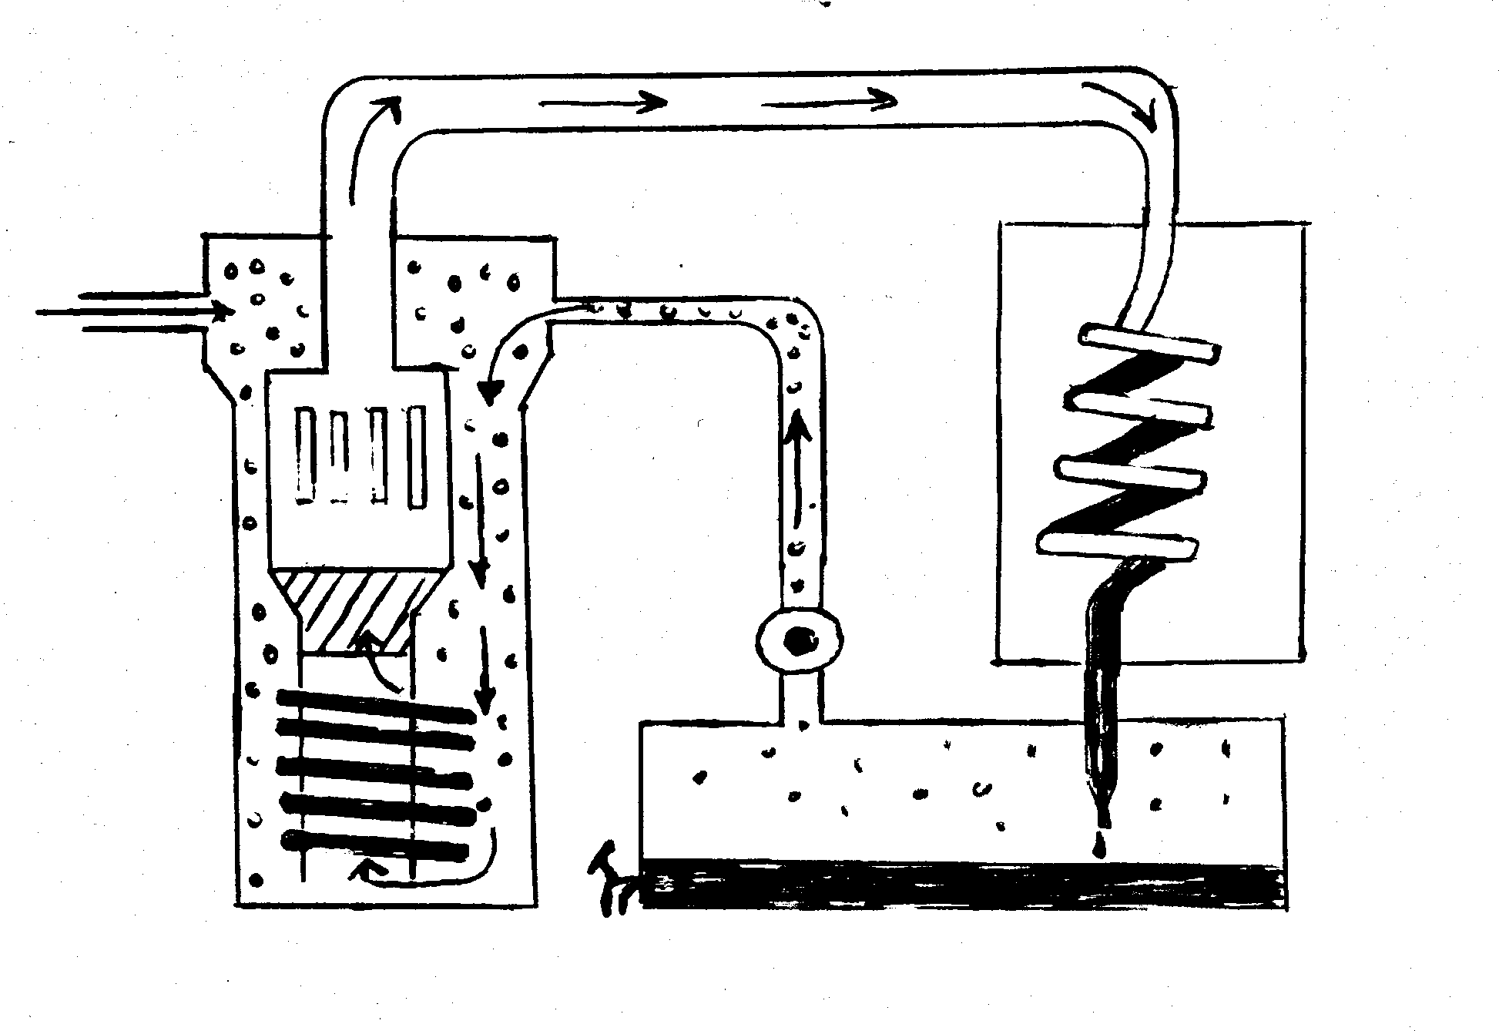
N₂ and H₂
Cooling Coil
Liquid Ammonia
Uncombined
N₂ and H₂
Recirculating
pump
Heat
Exchanger
Catalyst
Heating
Coil
Pressure = 350 atm
Unreacted N₂ and H₂

Starting from the entry of nitrogen and hydrogen at the top left of the diagram, describe the flow of these elements to the final product. Your response must include reasons as to why each part of the set-up is used. For example, why does the nitrogen and hydrogen pass through a heating coil? You must include equations and numeric values to show how a balance between maximum yield and minimum cost is achieved. Remember, a reaction that produces a lot of product (large equilibrium constant) may not be feasible because the reaction rate is too slow.

OR

Question 2

You are a chemistry teacher who is fascinated by the element chlorine. You decide to design a chlorine chemistry course for high school students. You believe that by focussing on chlorine and its reactions you will be able to cover a good deal of chemistry including acids and bases as well as redox reactions. Write an essay on how you would use chlorine and its reactions to teach about the various topics in chemistry you have familiarity with so far.
________________________________________________________________________

________________________________________________________________________

________________________________________________________________________

________________________________________________________________________

________________________________________________________________________

________________________________________________________________________

________________________________________________________________________

________________________________________________________________________

________________________________________________________________________

________________________________________________________________________

________________________________________________________________________

________________________________________________________________________

________________________________________________________________________

________________________________________________________________________

________________________________________________________________________

________________________________________________________________________

________________________________________________________________________

________________________________________________________________________

________________________________________________________________________

________________________________________________________________________

________________________________________________________________________

________________________________________________________________________

________________________________________________________________________

________________________________________________________________________

________________________________________________________________________

________________________________________________________________________

________________________________________________________________________

________________________________________________________________________

________________________________________________________________________

________________________________________________________________________

________________________________________________________________________

________________________________________________________________________

________________________________________________________________________

________________________________________________________________________

________________________________________________________________________

________________________________________________________________________

________________________________________________________________________

________________________________________________________________________

________________________________________________________________________

________________________________________________________________________

________________________________________________________________________

________________________________________________________________________

________________________________________________________________________

________________________________________________________________________

________________________________________________________________________

________________________________________________________________________

________________________________________________________________________

________________________________________________________________________

________________________________________________________________________

________________________________________________________________________

________________________________________________________________________

________________________________________________________________________

________________________________________________________________________

________________________________________________________________________

________________________________________________________________________

________________________________________________________________________

________________________________________________________________________

________________________________________________________________________

________________________________________________________________________

________________________________________________________________________

________________________________________________________________________

________________________________________________________________________

________________________________________________________________________

________________________________________________________________________

________________________________________________________________________

________________________________________________________________________

________________________________________________________________________

________________________________________________________________________

________________________________________________________________________

________________________________________________________________________

________________________________________________________________________

________________________________________________________________________

________________________________________________________________________

________________________________________________________________________

________________________________________________________________________

________________________________________________________________________

________________________________________________________________________

________________________________________________________________________

________________________________________________________________________

________________________________________________________________________

________________________________________________________________________

________________________________________________________________________

________________________________________________________________________

________________________________________________________________________

________________________________________________________________________

________________________________________________________________________

________________________________________________________________________

________________________________________________________________________

________________________________________________________________________

________________________________________________________________________

________________________________________________________________________

END OF PAPER

